Project Design Phase-II
Technology Stack (Architecture & Stack)

Date | 8th October 2026
Team ID | 9100FusionForce
Project Name | Script-Controlled ACL
Maximum Marks | 4 Marks

Technical Architecture:
The SkillWallet technical architecture is based on the ServiceNow platform, using server-side JavaScript ACL scripts, role-based access control, and the custom u_institution_details table.
Project: Script-Controlled ACL
Reference: SkillWallet project document (source for the documented technology stack and ACL implementation).

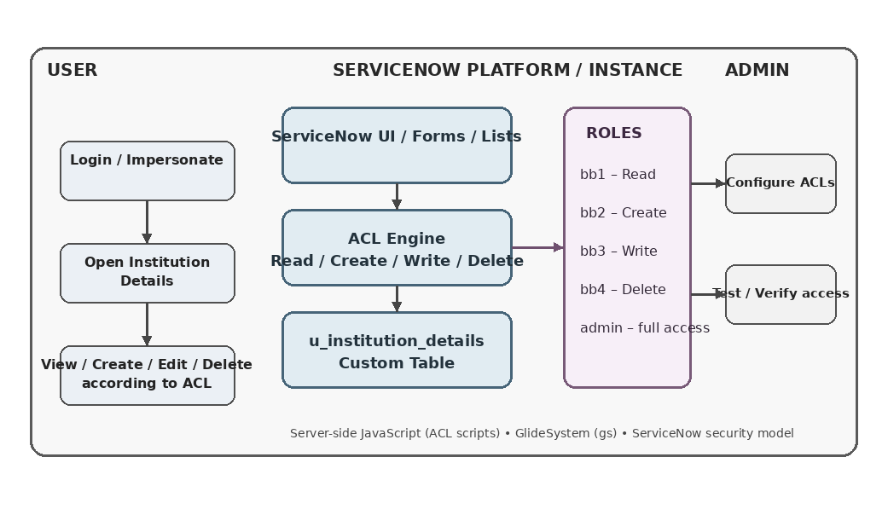

Table-1 : Components & Technologies:
S.No | Component | Description | Technology
1. | User Interface | ServiceNow lists/forms for Institution Details. | ServiceNow UI / Lists / Forms
2. | Application Logic-1 | Server-side ACL logic controls access by operation and role. | JavaScript ACL Scripts / GlideSystem (gs)
3. | Application Logic-2 | Not used in SkillWallet. | Not used
4. | Application Logic-3 | Not used in SkillWallet. | Not used
5. | Database | Stores Institution Details records and fields. | ServiceNow platform data store / u_institution_details
6. | Cloud Database | No separate cloud database is used. | Not separately used
7. | File Storage | No separate file-storage component is required. | Not used
8. | External API-1 | No external API is used. | None
9. | External API-2 | No external API is used. | None
10. | Machine Learning Model | No ML model is used. | None
11. | Infrastructure (Server / Cloud) | Runs within the ServiceNow platform/instance. | ServiceNow platform / instance

Table-2: Application Characteristics:
S.No | Characteristics | Description | Technology
1. | Open-Source Frameworks | No open-source framework is specified. | None specified
2. | Security Implementations | ACLs control Read/Create/Write/Delete using bb1–bb4; admin is allowed by the Read script. | ServiceNow ACLs / Role-based access / JavaScript
3. | Scalable Architecture | Implemented inside ServiceNow; no custom microservices or 3-tier design is specified. | ServiceNow platform
4. | Availability | No custom load-balancer or distributed-server design is specified. | ServiceNow platform-managed availability
5. | Performance | No quantitative benchmark, cache or CDN requirement is specified. | No specific benchmark specified

References:
https://www.servicenow.com/community/servicenow-ai-platform-forum/understanding-servicenow-acl-a-guide-for-admins-and-developers/m-p/3078304
https://www.servicenow.com/community/itsm-articles/access-control-lists-in-servicenow/ta-p/2304210
https://www.servicenow.com/community/architect-articles/servicenow-security-hardening-a-practical-checklist-for/ta-p/3605746
https://www.servicenow.com/community/platform-privacy-security-blog/planning-your-access-control-strategy/ba-p/3446016
https://c4model.com/
https://aws.amazon.com/architecture/security_identity_compliance/
https://www.ibm.com/architectures
https://medium.com/the-internal-startup/how-to-draw-useful-technical-architecture-diagrams-2d20c9fda90d

